DR. PANKAJ M. JOSHI
GOOGLE SCHOLAR CITATION METRICS

MS (General Surgery) | DNB (Urology, Gold Medal) | Reconstructive Urologist
Consultant Urologist, UROKUL Urology Institute, Pune, India
drpankajmjoshi@gmail.com • pankaj@drpankajjoshi.com • +91 99234 06464 • ORCID: 0000-0002-2233-7785 • Pune, India
PROFILE  Dr. Pankaj M. Joshi is a reconstructive urologist with a clinical and academic focus on urethral stricture disease, complex urethroplasty, pelvic fracture urethral injury, failed hypospadias repair and innovative tissue-preserving surgical techniques. He trained in General Surgery at B. Y. L. Nair Hospital and Topiwala National Medical College, University of Mumbai, and in Urology at Deenanath Mangeshkar Hospital, Pune. He received the H. S. Bhat Gold Medal after ranking first in the DNB Urology final examination in 2010. He has worked in reconstructive urology in Pune for more than 17 years and is associated with UROKUL, Pune.  AREAS OF EXPERTISE  Urethroplasty • Panurethral strictures • Pelvic fracture urethral injury • Bulbar urethral necrosis • Failed hypospadias • Female urethral reconstruction • Surgical innovation and video-based education  CURRENT APPOINTMENT  Head of Department — UROKUL Urology Institute, Pune  EDUCATION  - DNB (Urology), Deenanath Mangeshkar Hospital, Pune — H. S. Bhat Gold Medal, 2010.  - MS (General Surgery), B. Y. L. Nair Hospital / Topiwala National Medical College, University of Mumbai — highest in college; second in university.  - MBBS, Lokmanya Tilak Municipal Medical College, University of Mumbai.  LEADERSHIP & PROFESSIONAL SERVICE  - Former Board of Directors member, Society of Genitourinary Reconstructive Surgeons (GURS); served on the GURS Fellowship Committee.  - Former Secretary, International Society of Reconstructive Urology (ISORU); former Secretary, Urology Society of Pune; Treasurer, Urology Society of Pune (2017–2019).  - Member, WHO Technical Advisory Group on medical devices in male circumcision.  - Committee member, Urological Society of India guidelines for urethral stricture; committee member for SIU failed-hypospadias guidance (2018, Seoul).  - Faculty of Eminence Award and Honorary Fellowship, Indian School of Urology / Board of Education, Urology Society of India (2021). | COUNTRIES VISITED  International academic meetings, invited lectures and operative workshops documented in the CV.
  • Australia | • Nepal
  • Bahamas | • Netherlands
  • Bangladesh | • Nigeria
  • Belgium | • Oman
  • Brazil | • Philippines
  • Cameroon | • Poland
  • Canada | • Portugal
  • China | • Qatar
  • Egypt | • Scotland
  • Ethiopia | • Serbia
  • France | • Singapore
  • Germany | • South Africa
  • Greece | • South Korea
   | • Spain
  • Indonesia | • Switzerland
  • Italy | • Thailand
  • Kazakhstan | • Turkey
  • Kenya | • Uganda
  • Kuwait | • United Arab Emirates
  • Malaysia | • United Kingdom
  • Mexico | • United States
  • Morocco | • Zimbabwe
HONOURS, AWARDS & FELICITATIONS
- Best Video Award, Society of Robotic Surgery Meeting, New Delhi — for applying the non-transecting reconstructive principle to ureteral and bladder-neck surgery.
- Felicitated by the Governor of Rajasthan during the GURECON meeting, Jaipur.
- Chandigarh Best Video Prize for Enterourethroplasty video, Annual Urology Society of India Meeting, Kochi (2020).
- 2019: Vijayawada Best Poster Prize for novel DVIU techniques; Best Video, Pune Surgical Society; IAUA–AUA Best Poster Award, AUA Chicago.
- 2018: IAUA Chakraborty Fellowship, Cleveland Clinic; Best Poster Award for Vicryl tackers in buccal graft quilting, AUA San Francisco; Second Best Video Award, West Zone Urology Meeting, Raipur.
- 2017: Third Prize, BANTU, SIU Lisbon, for the Joshi–Kulkarni Clampotractor; Vijayawada Best Poster Prize, USICON Mumbai.
- 2016: C. K. P. Menon Best Paper, USICON Hyderabad, for “Are Urologists Getting French Fried?”; UAA–USI Fellowship, Singapore, with abstract considered for the “Best of the Best” category.
- 2015: Vijayawada Best Poster Prize for bulbar urethral necrosis after failed urethroplasty for pelvic fracture urethral distraction defects; Brij Kishore Patna Best Paper Prize for management of hypospadias cripple, USICON Ranchi.
- Vijayawada Best Poster Prize for management of panurethral stricture, USICON Bangalore (2012).
- Best Video Prize, WZUSICON, Khajuraho, for laparoscopic-assisted PCNL (2009).

TOTAL CITATIONS | CITATIONS SINCE 2021 | H-INDEX · ALL TIME | H-INDEX · SINCE 2021
2,507 | 1,629 | 27 | 22

Google Scholar profile snapshot accessed 13 October 2026. Citation metrics update automatically.

SURGICAL INNOVATIONS & TECHNICAL CONTRIBUTIONS
- Mucosal-sparing augmented non-transected anastomotic (MsANTA) urethroplasty for urethral strictures-Joshi step
- Application of the non-transecting reconstructive principle beyond the urethra, including ureteral reconstruction and bladder-neck surgery (recognised by Best Video Award at the Society of Robotic Surgery Meeting, New Delhi).
- Joshi–Kulkarni Clampotractor: a self-retaining penile retractor designed to improve surgical ergonomics in hypospadias and penile reconstruction.
- Use of Vicryl tackers for buccal mucosal graft quilting/fixation.
- MRI protocol for pelvic fracture urethral distraction defects and rectourethral fistula; 3D modelling/printing of pelvic fracture urethral injuries.
- Double-face buccal mucosal graft urethroplasty for female urethral strictures;
- Partial neurovascular bundle mobilisation in penile curvature correction; semi-mobilisation of the neurovascular bundle in hypospadias.
BOOKS EDITED
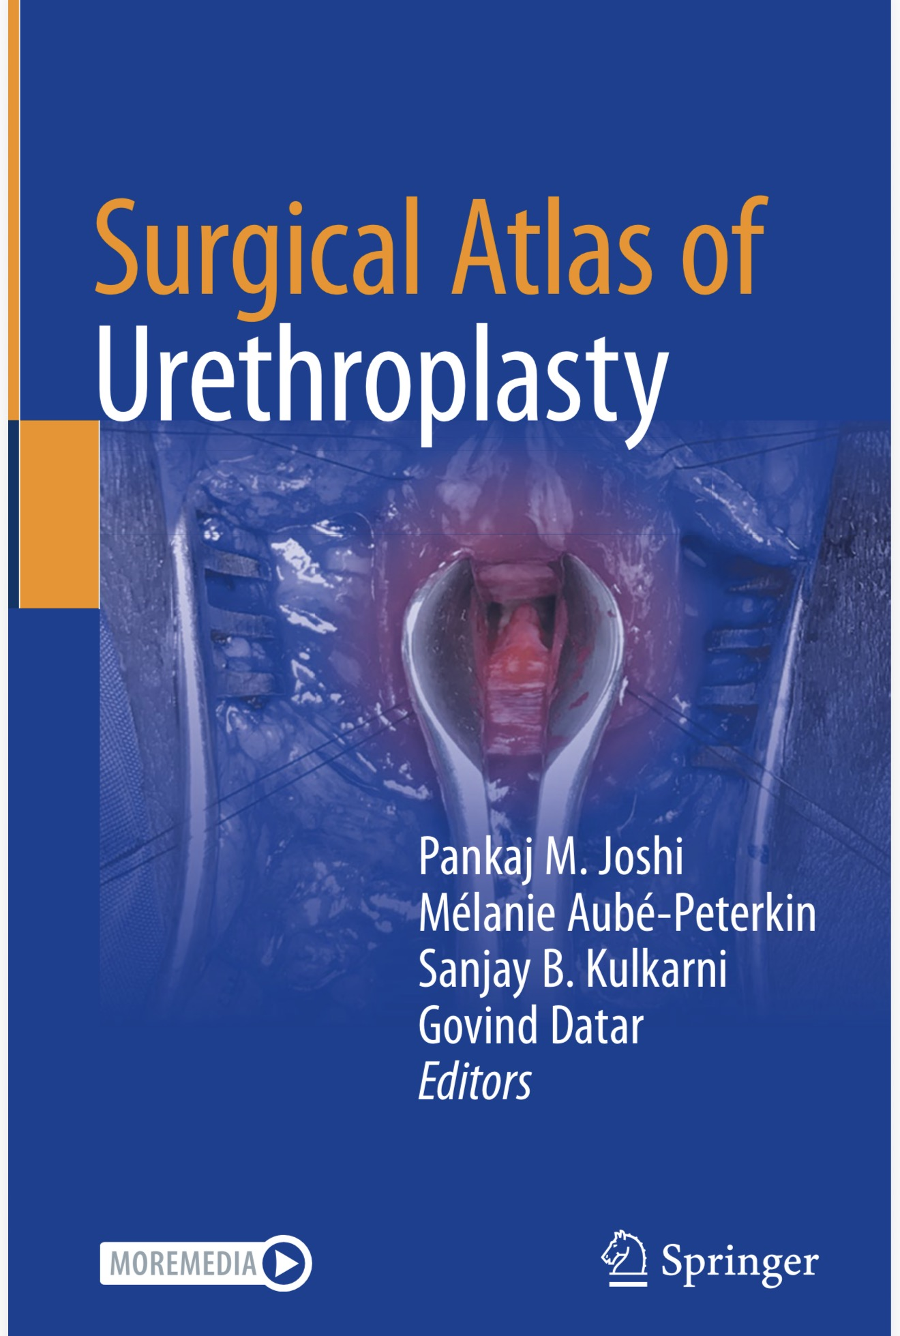  Surgical Atlas of Urethroplasty  Editors: Pankaj M. Joshi, Mélanie Aubé-Peterkin, Sanjay B. Kulkarni, Govind Datar  Springer Nature Singapore • 2024 copyright | 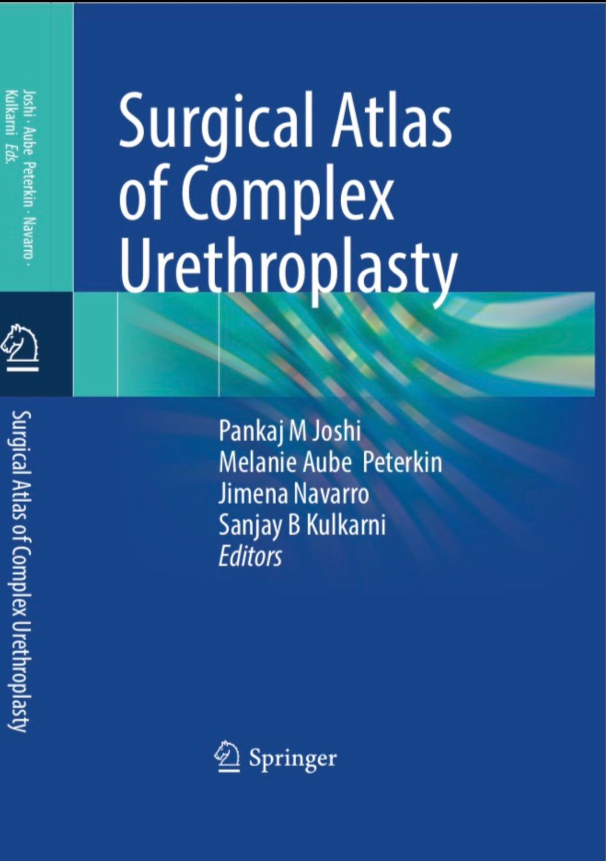  Surgical Atlas of Complex Urethroplasty  Editors: Pankaj M. Joshi, Mélanie Aubé-Peterkin, Jimena Navarro, Sanjay B. Kulkarni  Springer Nature Singapore • 2026
BOOK CHAPTERS & EDUCATIONAL PUBLICATIONS
1. Joshi PM, Desai DJ, Kulkarni SB. Bulbar urethral necrosis. In: Textbook of Male Genitourethral Reconstruction. Springer, Cham; 2020:345-351.
2. Kulkarni SB, Kulkarni J, Joshi PM. Use of bowel for urethral reconstruction. In: Textbook of Male Genitourethral Reconstruction. Springer, Cham; 2020:371-374.
3. Kulkarni SB, Joshi P, Pérez EA. Surgical reconstruction of pelvic fracture urethral injury. In: Textbook of Male Genitourethral Reconstruction. Springer, Cham; 2020:253-265.
4. Joshi PM, Kulkarni SB. Management of urethral injuries associated with complex pelvic fracture. In: Textbook of Male Genitourethral Reconstruction. 2019.
5. Joshi PM, Alhajeri F, Kulkarni SB. Surgical reconstruction of panurethral stricture disease. In: Textbook of Male Genitourethral Reconstruction. 2019.
6. Kulkarni SB, Joshi PM. Muscle-, nerve-, and vascular-sparing techniques in anterior urethroplasty. In: Advanced Male Urethral and Genital Reconstructive Surgery. Humana Press; 2014:481-492.
7. Joshi P, Bandini M, Kulkarni SB. Imaging in stricture urethra: anastomotic urethroplasty. In: Atlas of Urethral Surgery. Editors: Rajesh Gulia, Richard Santucci.
8. Joshi P, Bandini M, Kulkarni SB. Management of urological problems in Parkinson’s disease. In: Textbook of Male Vesicourethral Reconstruction.
9. Joshi P, Kulkarni SB, Viswaroop B, Gopalakrishnan G. Management of pelvic fracture urethral injury in females. Textbook chapter.
10. Joshi PM, Bandini M, Kulkarni SB. Use of common flaps in genitourinary reconstruction. Urol Clin North Am. 2022. doi:10.1016/j.ucl.2022.04.001.
11. Joshi P, Kulkarni SB. Anastomotic urethroplasty for pelvic fracture urethral injury. BJUI Knowledge video module; 2017. doi:10.18591/BJUIK.V009.
12. Kulkarni S, Joshi P. Management of panurethral strictures with the Kulkarni technique. BJUI Knowledge video module; 2018. doi:10.18591/BJUIK.V018.
13. Joshi P, Kulkarni SB. Pedicled preputial tube urethroplasty for long gaps after failed urethroplasty for PFUDD. BJUI Knowledge video module; 2018.
INTERNATIONAL FACULTY, VISITING PROFESSORSHIPS & WORKSHOPS
- Selected podium and invited presentations: AUA Annual Meetings (Boston 2017, Chicago 2019, Washington 2026); SIU Annual Meetings (Athens 2019, Istanbul 2023); EAU Annual Meeting, Milan (complex urethral reconstruction); AUA/SIU/USICON and regional urology society meetings.
- International live urethroplasty workshops and faculty activity documented in the CV: Barcelona, Spain (2024); Madrid, Spain; Kuala Lumpur, Malaysia; Guadalajara, Mexico; Salvador, Brazil; Istanbul, Turkey; Warsaw, Poland; Pretoria, South Africa (2023); Doha, Qatar; Alexandria, Egypt; Kathmandu, Nepal; Nairobi, Kenya; Indonesia; Muscat, Oman; Bangladesh; Nigeria; Zimbabwe; Bahamas (2013–2019).
- National teaching: recurrent faculty and live surgery workshops at USICON, ISORU, GURECON, PENRECON, West Zone and North Zone Urology Society meetings; workshop activity in Pune, Mumbai, Delhi, Jaipur, Hyderabad, Ahmedabad, Jodhpur, Trichy, Chennai, Latur, Aurangabad, Nashik, Jammu, Patna, Ranchi and other Indian centres.
- Convener, I-Ture resident training series on urethral strictures (from 2021); reconstructive urology sessions at USICON 2020 and subsequent annual meetings; visiting professor at Fundación Puigvert, Barcelona (2024); demonstrated live Kulkarni urethroplasty at the SIU Annual Meeting, Athens (2019).
SELECTED INVITED LECTURES & ACADEMIC ROLES
- 2026: Faculty/presentations at meetings in Mexico, Cameroon, London, Uganda, Turkey, Australia and the United States (AUA Washington), as well as academic meetings in India.
- 2025: Faculty/presentations at meetings in the United States, Spain, Kuwait, Indonesia, Bangladesh, Germany, Mexico, the Philippines and Australia; online contribution to Pakistan; meetings in India and at SIU.
- 2024: Reconstructive urology sessions at USICON (Patna); live urethroplasty workshops at Fundación Puigvert, Barcelona, LTMMC Sion Mumbai and North Zone Urology Society Mid-term meeting, Jammu; visiting professor, Fundación Puigvert.
- 2023: Live workshops in Spain, Malaysia, Mexico, Brazil, Turkey, Poland and South Africa; reconstructive sessions at USICON New Delhi, Oman Urological Association, Brazilian and Mexican annual meetings, and SIU Istanbul; invited lecture at EAU Milan.
- 2021 onward: Convener, I-Ture resident training series on urethral strictures; convened training on panurethral stricture, pelvic fracture urethral injury and failed hypospadias for international urology groups.
- 2020: Convener, Reconstructive Urology Session, USI Annual Meeting, Kochi; reconstructive urology session at SIU virtual meeting; invited video lectures for urology associations including Indonesia, the Philippines and the Emirates.
- 2019: Live Kulkarni urethroplasty at SIU Athens; reconstructive urology program at USI Annual Meeting and WZUSICON Rajkot; lectures in Doha, Alexandria and Hyderabad; moderated pelvic fracture session at AUA Chicago.
- 2018: Lectures/workshops in Portugal, the Bahamas, Nepal, Egypt, UAE and the United States; invited presentation on failed hypospadias at Cleveland Clinic.
- 2017: AUA Boston plenary on panurethral strictures; presentations at SIU Lisbon, UROMEET New Delhi, PENRECON Ahmedabad and complex urethroplasty workshops in Nepal.
PROFESSIONAL MEMBERSHIPS, REVIEWING & LANGUAGES
Professional memberships: Urological Society of India (USI); Société Internationale d’Urologie (SIU); American Urological Association (AUA); Society of Genitourinary Reconstructive Surgeons (GURS); International Society of Reconstructive Urology (ISORU); European Association of Urology (EAU).
Journal/book reviewer: Journal of Urology; BJU International; SIU Journal; World Journal of Urology; Asian Journal of Urology; Indian Journal of Urology; and other peer-reviewed journals.
Languages: English, Hindi and Marathi.
Research and clinical trial experience: Study coordinator for trials on a polymer intended to prevent back-migration of ureteric calculi during intracorporeal lithotripsy and an endothelin-receptor antagonist in prostate carcinoma; co-investigator in a prospective randomised trial of tissue-engineered buccal cells after DVIU for short bulbar strictures.

JOURNAL ARTICLES, EDITORIALS & RELATED PUBLICATIONS |
1. El Anzaoui J, Akjay A, Lakrabti N, Jmil N, Ettoumi N, Dominique Nguema L, Bidan S, Joshi P. How I Do It: Multilayer Repair of Recurrent Urethrocutaneous Fistula Using a Cutaneous Flap. ANZ J Surg. 2026. doi:10.1111/ans.70695.
2. Thakkar S, Joshi P, Bhadranavar S, Navarro J, Barot P, Kandhari P, Kulkarni S. Patient-reported outcomes after single-stage spiral preputial graft urethroplasty for panurethral strictures: a single-centre prospective study. BMC Urol. 2026;26(1):69. doi:10.1186/s12894-026-02070-z.
3. Joshi PM, Navarro J, Ratanapornsompong W, Ocampo MA, De Win G, Thiessen F, Wood D, Kulkarni SB. Pedicled tubularized flaps for the treatment of bulbar urethral necrosis. World J Urol. 2026;44(1):125. doi:10.1007/s00345-026-06223-5.
4. Joshi P, Navarro J, Ratanapornsompong W, Bandini M, Kulkarni SB. The mucosal-sparing augmented non-transected anastomosis (MsANTA) principle for tubular organs. BJU Int. 2026;137(3):454-455. doi:10.1111/bju.70122.
5. Cannoletta D, Pederzoli F, Yepes C, Joshi P, Salonia A, Briganti A, Montorsi F, Kulkarni S, Bandini M. Evolution and innovation in urethroplasty: a comprehensive narrative review of graft types and surgical techniques. Int J Impot Res. 2026;38(4):269-275. doi:10.1038/s41443-025-01040-7.
6. Joshi P, Navarro J, Ocampo MA, De Win G, Thiessen F, Wood D, Bhadranavar S, Talpallikar A, Kulkarni SB. Bulbar urethral necrosis: current concept and novel comprehensive classification. BJU Int. 2025;136(1):103-108. doi:10.1111/bju.16710.
7. Bain M, Gomez Zapata DE, Ravichandran K, Fogaing C, Anand A, Bhirud DP, Bhadranavar S, Kulkarni S, Desai D, Joshi P. Female urethral stricture: a multi-centre experience and lessons learnt. BJUI Compass. 2025;6(5):e70024. doi:10.1002/bco2.70024.
8. Calvo CI, Buckley JC, Joshi P, Peterson A, Wood H, Simhan J, Rourke KF. Experiences and outcomes of the Society of Genitourinary Reconstructive Surgeons fellowship training: growth in fellowships mirrors the evolution of the discipline. Urology. 2025;195:250-257. doi:10.1016/j.urology.2024.09.035.
9. Bandini M, Joshi P, Bafna S, Yepes C, Alrefaey A, Longoni M, Montorsi F, Kulkarni S. Establishing the role of single-stage preputial spiral graft urethroplasty for panurethral stricture. BJU Int. 2025;136(4):640-646. doi:10.1111/bju.16796.
10. Joshi P, Kulkarni S, Albanese N, Negri F, Bandini M. Single-stage pedicled preputial tube substitution urethroplasty with corpora cavernosa augmentation using buccal mucosa graft for primary peno-scrotal hypospadias repair in adults. Int Braz J Urol. 2025;51(4):e20240650. doi:10.1590/S1677-5538.IBJU.2024.0650.
11. Bandini M, Joshi P, Kulkarni SB. Future directions in urethroplasty: emphasising mucosal preservation and reducing graft dependency. BJU Int. 2024;133(3):351. doi:10.1111/bju.16196.
12. Joshi P, Albanese N, Bhadranavar S, Cattafi F, Salonia A, Montorsi F, Kulkarni S, Bandini M. Total bulbospongiosum muscle sparing for bulbar urethroplasty: beyond the one-sided dissection. BJU Int. 2024;134(6):1010-1013. doi:10.1111/bju.16446.
13. Kulkarni SB, Joshi PM, Bhadranavar S. Advances in urethroplasty. Med J Armed Forces India. 2023;79(1):6-12. doi:10.1016/j.mjafi.2022.12.002.
14. Hevia Palacios M, Joshi PM, Sreeranga YL, Bandini Zoli M, Patil A, Bhadranavar S, Sharma V, Bafna S, Kulkarni SB. Double-face urethroplasty in patients with obliterative bulbar strictures post-transurethral resection of prostate: mid-term outcomes in a high-volume referral centre. Asian J Urol. 2023;10(4):512-517. doi:10.1016/j.ajur.2021.11.001.
15. Joshi P, Bandini M, Kulkarni SB. Mucosal-sparing augmented non-transected anastomotic (MsANTA) urethroplasty: a step forward in ANTA urethroplasty. BJU Int. 2022;130(1):133-136. doi:10.1111/bju.15734.
16. Joshi PM, Bandini M, Bafna S, Sharma V, Patil A, Bhadranavar S, Yepes C, Barbagli G, Montorsi F, Kulkarni SB. Graft plus fasciocutaneous penile flap for nearly or completely obliterated long bulbar and penobulbar strictures. Eur Urol Open Sci. 2021;35:21-28. doi:10.1016/j.euros.2021.10.009.
17. Joshi P, Bandini M, Yepes C, Bafna S, Bhadranavar S, Sharma V, Cirulli GO, Kulkarni S. Flaps for bulbar urethral ischemic necrosis in pelvic fracture urethral injury. Plast Aesthet Res. 2022;9:22.
18. Joshi P, Bandini M, Yepes C, Bafna S, Bhadranavar S, Sharma V, Kulkarni S. Management of female pelvic fracture urethral injury. Société Internationale d’Urologie Journal. 2022;3(2):77-86. doi:10.48083/MBXR6354.
19. Sreeranga YL, Joshi PM, Bandini M, Kulkarni SB. Comprehensive analysis of paediatric pelvic fracture urethral injury: a reconstructive centre experience. BJU Int. 2022;130(1):114-125. doi:10.1111/bju.15686.
20. Bandini M, Yepes C, Joshi PM, Basile G, Naranjo D, Bhadranavar S, Alrefaey A, Bafna S, Montorsi F, Kulkarni SB. Which are the commonest sites and characteristics of post-transurethral prostate surgery strictures in a high-volume reconstructive centre? J Endourol. 2022. doi:10.1089/end.2022.0130.
21. Kulkarni SB, Joshi PM, Bandini M, Morey AF, Santucci RA, Fisch M, Djinovic R, Montorsi F, Barbagli G, Mundy T. Reply: Female urethra—Is ventral the true dorsal? Eur Urol. 2022;81(1):e14-e15. doi:10.1016/j.eururo.2021.09.031.
22. Basile G, Karakiewicz PI, Tian Z, Djinovic R, Montorsi F, Barbagli G, Joshi P, Kulkarni SB, Bandini M. The impact of surgical volume on perioperative safety after urethroplasty: a population-based study. Minerva Urol Nephrol. 2022. doi:10.23736/S2724-6051.22.04893-5.
23. Ballesteros Ruiz C, Bandini M, Joshi PM, Bafna S, Sharma V, Yatam SL, Bhadranavar S, Patil A, Kulkarni SB. Dorsal approach for double-face bulbar urethroplasty: ventral inlay plus dorsal onlay using Kulkarni one-side dissection. Int Urol Nephrol. 2022;54(5):1039-1045. doi:10.1007/s11255-022-03158-9.
24. Bandini M, Ahmed M, Basile G, Watkin N, Master V, Zhu Y, Prakash G, Rodriguez A, Ssebakumba MK, Leni R, Cirulli GO, Ayres B, Compitello R, Pederzoli F, Joshi PM, Kulkarni SB, Montorsi F, Sonpavde G, Necchi A, Spiess PE. A global approach to improving penile cancer care. Nat Rev Urol. 2022;19(4):231-239. doi:10.1038/s41585-021-00557-y.
25. Sterling J, Schardein J, Joshi PM, Kulkarni SB, Nikolavsky D. Long-term outcomes from a multi-institutional experience with prefabricated composite gracilis-buccal mucosal flap for reconstruction of devastated urethras. Int Urol Nephrol. 2022;54(5):1047-1052. doi:10.1007/s11255-022-03154-z.
26. Joshi P. Female bladder outlet obstruction and urethral reconstruction. Indian J Urol. 2021;37(3):300-301. doi:10.4103/iju.iju_246_21.
27. Bandini M, Barbagli G, Joshi PM, Leni R, Cirulli GO, Basile G, Balo S, Montorsi F, Sansalone S, Salonia A, Briganti A. Impact of perioperative complications on length of hospitalizations, readmission rate and treatment failure after urethroplasty. Eur Urol. 2021;79(Suppl):S574 (conference abstract).
28. Bandini M, Barbagli G, Leni R, Cirulli GO, Basile G, Balo S, Montorsi F, Sansalone S, Salonia A, Briganti A, Butnaru D, Lazzeri M. Assessing in-hospital morbidity after urethroplasty using the European Association of Urology quality criteria for standardized reporting. World J Urol. 2021;39(10):3921-3930. doi:10.1007/s00345-021-03692-8.
29. Joshi P. Editorial comment on triangular extension of hinge flaps to resolve stomal stenosis and prevent restenosis in staged buccal mucosal urethroplasty. Int J Urol. 2021;28(8):813.
30. Spinoit AF, Waterschoot M, Sinatti C, Abbas T, Callens N, Cools M, Hamid R, Hanna MK, Joshi P, Misseri R, Salle JLP, Roth J, Tack LJW, De Win G. Fertility and sexuality issues in congenital lifelong urology patients: male aspects. World J Urol. 2021;39(4):1013-1019.
31. Shaw NM, Mallahan C, Joshi P, Venkatesan K, Kulkarni S. Novel use of Asopa technique for penile urethrocutaneous fistula repair. Int Urol Nephrol. 2021;53(6):1127-1133.
32. Kulkarni SB, Bhat A, Bhatyal HS, Sharma GR, Dubey DD, Khattar N, Panda A, Dangi A, Batra VS, Joshi PM. The Urological Society of India guidelines for the management of urethral stricture: executive summary. Indian J Urol. 2021;37(1):6-9.
33. Joshi PM, Desai D, Fuziwara S, Raveenthiran S, Nafea M, Kulkarni SB. Redo pelvic fracture urethral injury repair: the case for tadalafil. Turk J Urol. 2021;47(4):319-324.
34. Joshi PM, Bandini M, Barbagli G, Hevia M, Montorsi F, Kulkarni SB. Partial mobilisation of the neurovascular bundle for ventral penile curvature correction: a proof-of-concept study. J Clin Urol. 2021.
35. Kulkarni SB, Bandini M, Patil A, Bhadranavar S, Sharma V, Bafna S, Yatam SL, Barbagli G, Montorsi F, Joshi PM. The right instrument for the right purpose: spreading the use of small calibre ureteroscope for inspection of the male and female urethra. Société Internationale d’Urologie Journal. 2021;2(4).
36. Joshi PM, Desai DJ, Hunter C, Shahrour W, Kulkarni SB. Are urologists getting French-fried? Discrepancy between advertised and actual sizes of endourology instruments. J Urol Ren Dis. 2021;6:1218.
37. Joshi P, Bandini M, Montorsi F, Kulkarni SB. Challenging the dogma of six steps for anastomotic urethroplasty in posterior urethral stricture: introducing step 3a. World J Urol. 2021.
38. Joshi PM, Desai DJ, Shah D, Joshi DP, Kulkarni SB. Magnetic resonance imaging procedure for pelvic fracture urethral injuries and rectourethral fistulas: a simplified protocol. Turk J Urol. 2021;47(1):35-42. doi:10.5152/tud.2020.20472.
39. Agrawal M, Saraf S, Saraf S, Murty US, Kurundkar SB, Roy D, Joshi P, Sable D, Choudhary YK, Kesharwani P, Alexander A. In-line treatments and clinical initiatives to fight against the COVID-19 outbreak. Respir Med. 2020;106192.
40. Kulkarni SB, Joglekar O, Alkandari M, Joshi PM, Favorito LA. Editorial comment: management of post-TURP strictures. Int Braz J Urol. 2019;46:126-127.
41. Chen L, Feng C, Lv XG, Fan HH, Joshi P, Barbagli G, Zhao YM, Xu YM, Li Z, Hu B, Fu Q. Three-dimensional computerized model based on the sonourethrogram: a novel technique to evaluate anterior urethral stricture. J Urol. 2018;199(2):568-575.
42. Shahrour W, Joshi P, Hunter CB, Batra VS, Elmansy H, Surana S, Kulkarni S. The benefits of using a small-calibre ureteroscope in evaluation and management of urethral stricture. Adv Urol. 2018;2018:9137892.
43. Desai DJ, Joshi PM, Iyer S, Orabi H, Surana S. Panurethral strictures: a review of management options. Urol Nephrol Open Access J. 2017;4(6):00153.
44. Joshi P, Kulkarni S. Clampotractor: a novel self-retaining clamp retractor for penile urethral reconstruction, improving surgeon ergonomics. J Urol. 2017;197(4 Suppl):e69-e70.
45. Joshi PM, Kulkarni SB, Barbagli G, Butnaru D, Sansalone S, Lazzeri M. New technique of double-face buccal mucosal graft urethroplasty for female urethral strictures. BJUI Knowledge video publication.
46. Joshi PM, Kulkarni SB, Batra V, Barbagli G, et al. Penile urethroplasty using Orandi’s dorsal skin flap: a new technique. BJU Int. 2019;124(5):892-896. doi:10.1111/bju.14881.
47. Joshi P, Kulkarni SB. Three-dimensional printing of pelvic fracture urethral injuries. Turk J Urol. doi:10.5152/tud.2019.19165.
48. Joshi P, Kulkarni SB. A new technique of double-face buccal mucosal graft urethroplasty in female urethral strictures. Turk J Urol. doi:10.5152/tud.2019.19228.
49. Joshi P, Kulkarni SB. Management of pelvic fracture urethral injuries in the developing world. World J Urol. doi:10.1007/s00345-019-02918-0.
50. Kulkarni SB, Orabi H, Cavanagh A, Joshi PM. Re-redo urethroplasty after multiple failed surgeries for pelvic fracture urethral injuries. World J Urol. 2019. doi:10.1007/s00345-019-02917-1.
51. Joshi PM, Raveenthiran S, Desai DJ, Kulkarni J, Kulkarni SB. Vicryl tack for graft fixation during bulbar urethroplasty. Trends Urol Men’s Health. 2019. doi:10.1002/tre.705.
52. Kulkarni SB, Joglekar O, Alkandari M, Joshi PM. Management of post-TURP strictures. World J Urol. 2019;37(4):589-594.
53. Controversies in management of pelvic fracture urethral distraction defects. Turk J Urol. 2019;45(1):1-6.
54. Barbagli G, Kulkarni SB, Joshi PM, Nikolavsky D, Montorsi F, Sansalone S, Loreto C, Lazzeri M. Repair of sphincter urethral strictures preserving urinary continence: surgical technique and outcomes. World J Urol. 2019. doi:10.1007/s00345-019-02686-x.
55. Kulkarni SB, Joglekar O, Alkandari M, Joshi PM. Algorithm for the management of anterior urethral strictures. Turk J Urol. 2018;44(3):195-197.
56. Kulkarni SB, Joglekar O, Alkandari M, Joshi PM. Redo hypospadias surgery: current and novel techniques. Curr Res Rep Urol. 2018;10:117-126.
57. Urethral reconstruction in patients previously treated with Memokath urethral endoprosthesis. Actas Urol Esp. 2019;43(1):26-31.
58. Angulo JC, Kulkarni S, Joshi P, Nikolavsky D, Suarez P, Belinky J, Virasoro R, DeLong J, Martins FE, Lumen N, Giudice C, Suarez OA, Menendez N, Capiel L, Lopez-Alvarado D, Ramirez EA, Venkatesan K, Husainat MM, Esquinas C, Arance I, Gomez R, Santucci R. Urethroplasty after urethral UroLume stent: an international multicentre experience. Urology. 2018;118:213-219. doi:10.1016/j.urology.2018.04.031.
59. Joshi P, Kulkarni SB. A novel method for decision-making in diagnosis of anterior urethral strictures using methylene blue dye. Turk J Urol. Accepted for publication, 2017 (citation as listed in prior CV).
60. Kulkarni SB, Joglekar O, Joshi P, Surana S, Kulkarni S. Re-redo urethroplasty in pelvic fracture urethral defects. BJU Int. 2018;121:44-45 (meeting abstract).
61. Joshi PM, Desai DJ, Shah D, Joshi D, Kulkarni SB. Injury in pelvic fracture urethral injury is membranobulbar: fact or myth. Urology. 2017;102.
62. Joshi PM, Barbagli G, Batra V, Kulkarni SB, et al. A novel composite two-stage urethroplasty for complex penile strictures: a multicentre experience. 2017;33(2):155-158 (citation as listed in prior CV).
63. Martins FE, Kulkarni SB, Joshi P, Warner J, Martins N. Management of long-segment and panurethral stricture disease. Adv Urol. 2015;2015:853914.
64. Kulkarni S, Kulkarni J, Surana S, Joshi PM. Management of panurethral stricture. Urol Clin North Am. 2017;44(1):67-75.
65. Joshi P, Kaya C, Kulkarni S. Approach to bulbar urethral strictures: which technique and when? Turk J Urol. 2016;42:53-59.
66. Kulkarni S, Joshi P, et al. Management of panurethral strictures. Afr J Urol. 2016.
67. Kulkarni SB, Joshi P, Hunter C, Surana S, Shahrour W, Alhajeri F. Complex posterior urethral injury. Arab J Urol. 2015;13:43 (citation as listed in prior CV).
68. Warner JN, Malkawi I, Dhradekh, Joshi PM, et al. A multi-institutional evaluation of the management and outcomes of long-segment urethral strictures. Urology. 2015;85(6):1483-1487.
69. Kulkarni SB, Barbagli G, Joshi PM, Hunter C, Shahrour W, Kulkarni J, Sansalone S, Lazzeri M. Laparoscopic omentoplasty to support anastomotic urethroplasty in complex and redo pelvic fracture urethral defects: a stage-2 study. Urology. 2015;85(5):1200-1205.
70. Barbagli G, Kulkarni SB, Fossati N, Larcher A, Sansalone S, Guazzoni G, Romano G, Joshi PM, et al. Long-term follow-up and deterioration rate of anterior substitution urethroplasty. J Urol. 2014;192(3):808-813.
71. Kulkarni SB, Joshi P, Venkatesan K. Management of panurethral stricture disease in India. J Urol. 2012;188(3):824-830.
72. Joshi PM, Date J, Shivde SR, et al. Laparoscopic ureteroureterostomy for retrocaval ureter. J Endourol Part B: Videourology. 2010;24(2).
73. Deshmukh H, Shivde S, Date J, Langer R, Joshi P, Sadawarte N. Videourology publication. 2011. doi:10.1089/vid.2011.0003.
74. Joshi P, Date J, et al. Primary perinephric lymphoma. Internet J Surg. 2010;24(1).
75. Deuskar J, Joshi P, et al. Signet ring cell carcinoma of the ileum: a case report and review of literature. Internet J Surg. 2010;25(1).
76. Shivde SR, Date J, Joshi PM. Unusual causes of obstruction to transplant ureter: a case report with review of rare causes. Saudi J Kidney Dis Transpl. 2010;21(2):310-313.
77. Joshi P, Shivde S, et al. Testicular filariasis masquerading as a testicular tumour: case report and review of literature. Internet J Surg. 2010;23(1).
78. Shivde S, Joshi P, Date J, et al. Ileocecectomy with augmentation cystoplasty in ureteric stricture due to genitourinary disease. Br J Urol. 2009.
79. Shivde SR, Joshi PM, et al. Laparoscopic transperitoneal surgery for adrenal cysts. Internet J Surg. 2008;17(2).
80. Joshi PM, Shivde S, et al. Knotting of guide wires: a rare complication during a minimally invasive renal procedure—lessons learnt. J Minim Access Surg. 2008;4(4).
81. Shivde S, Joshi P, et al. Extrusion of double-J stent: a rare complication. Urology. 2008:814-815.
82. Joshi P, Kulkarni SB. Incidence and predictors of complications due to urethral stricture in patients awaiting urethroplasty: editorial comment. J Urol. 2018;199(3):758-759.
SELECTED POSTER PRESENTATIONS
1. Use of Vicryl tackers for quilting buccal graft — IAUA–AUA, San Francisco (2018).
2. Adipose-derived stromal vascular fraction injection after DVIU in short recurrent bulbar strictures — AUA, Boston (2017).
3. Changing trend in management of panurethral strictures using single-stage buccal graft dorsal onlay augmentation urethroplasty — AUA, San Diego (2016).
4. Management of bulbar urethral necrosis — AUA, Orlando (2014).
5. Management of panurethral stricture disease — USICON, Bangalore (2012; Vijayawada Best Poster Prize).
6. Primary perinephric lymphoma; super-selective microembolisation of bleeding renal pseudoaneurysms and AV fistulas — USICON, Indore (2009).
7. Ileocalicostomy with augmentation cystoplasty in genitourinary tuberculosis; testicular microfilariasis; knotting of guide wires; congenital megaureter — WZUSICON, Sholapur (2008).
8. Bladder manifestations of chikungunya fever — USICON (2008; first prize, co-author).
9. Medullary carcinoma of thyroid with absent isthmus — MASICON (2007); solitary thyroid nodules — Royal College of Surgeons of Edinburgh Conference, Hong Kong (2006).

SELECTED PAPER PRESENTATIONS
1. Magnetic resonance imaging to evaluate gap length in pelvic fracture urethral injuries — AUA, Boston (2017).
2. Most effective use of buccal graft in management of hypospadias cripple — AUA, New Orleans (2015).
3. Management of complex penile urethral strictures using staged urethroplasty — UAA, Shanghai (2015).
4. Management of female urethral trauma — WZUSICON, Baroda (2014); management of failed PFUDD — USICON, Pune (2013).
5. Management of panurethral stricture — WZUSICON, Goa (2011); HoLEP — WZUSICON, Khajuraho (2009).
6. Role of percutaneous nephrostomy urine culture in prevention of urosepsis in PCNL — USICON, Indore (2009); bipolar TURP experience — WZUSICON, Sholapur (2008).
7. Acute pancreatitis and experience with 1,000 solitary thyroid nodules — MASICON (2007).
SELECTED VIDEO PRESENTATIONS
1. Long-term follow-up of a novel two-stage urethroplasty technique for complex penile strictures — AUA, Chicago (2019).
2. Pedicled preputial tube urethroplasty for bulbar urethral necrosis — AUA, San Francisco (2018).
3. Clampotractor: a self-retaining clamp retractor for penile reconstructive surgery — AUA, Boston (2017); SIU, Lisbon (2017).
4. Management of double block at bladder neck/prostate and bulbomembranous urethra after pelvic fracture urethral injury.
5. Laparoscopy-assisted PCNL — WZUSICON, Khajuraho (2009; first prize); laparoscopic ureteroureterostomy for retrocaval ureter; flexible endoscopes and laser for difficult endourology procedures.
6. Leiomyoma of the female urethra; a novel polymer to prevent back migration of ureteric calculi (second prize, co-author) — WZUSICON, Sholapur (2008).
REFERENCES
Professional references available on request. Previous CV lists Dr Sanjay B. Kulkarni and Dr Anthony Mundy as referees.

